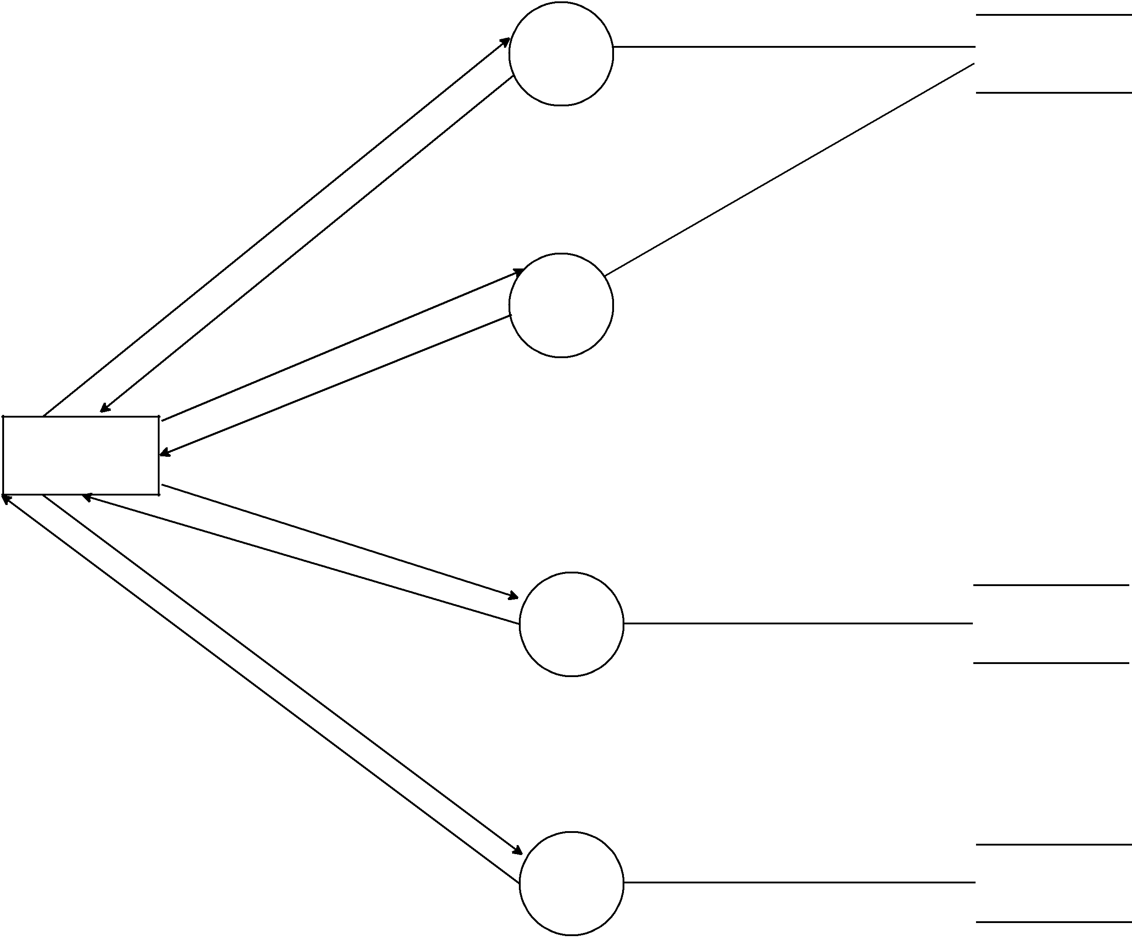

Request

Confirmation

Create
Pin

Confirmation

Admin

Request

Confirmation

Request

Confirmation
1.1

Login

1.2

Create

Pin

1.3

Customer

Information

1.4

Customer

Transaction

Info

Login

Update_Account

Emp_Create_Tran

